English version:

# Guiding Principle：

# Combination of Inheritance and Innovation(final version)

Lv Yanlin

THE MAIN AIMS:

1. Publicity methods - online promotion, offline irregular small activities

2. Communication(with other institutions and organizations) - Communicate with clubs and other colleges

3. Rights - identifying and resolving issues

The official platform is already very complete, now consider:

1) Promote SRC more frequently

2) Try to take a more informal direction

1. **Inheritance**

The main purpose of inheritance is to standardize student work. The standardization here refers to neither patternization nor routinization, but rather to the ability to efficiently organize activities, reduce failures, and make students feel more involved in the activities.

* 1. The process of organizing activities: The specific implementation method for this is experience summary

It is necessary to summarize experience. For example, when encountering a temporary price increase during the ball this year, how to solve it and how to avoid it can be summarized by organizers and provided to future organizers for reference. Avoid such detours and similar problems, then the event will be better and better. The feasibility of this plan lies in the fact that large-scale events have similar processes and encounter similar problems.

There are two problems with this measure, and I have also proposed possible solutions respectively.

Firstly, it may limit students' imagination of the activity and causing the activities stick to the previous versions without any innovation and new ideas. This can be summarized through experience and submitted to the presidium, who will collect them and sort them. Then after students have finalized the planning plan, presidium will provide these files to the next class of students for reference.

Secondly, it will increase the workload of organizers and every organizer might write experience summary differently. The solution is to develop a rough plan (activity schedule - problem 1- how to solve 1- how to avoid 1- problem 2...)

example(written by me):

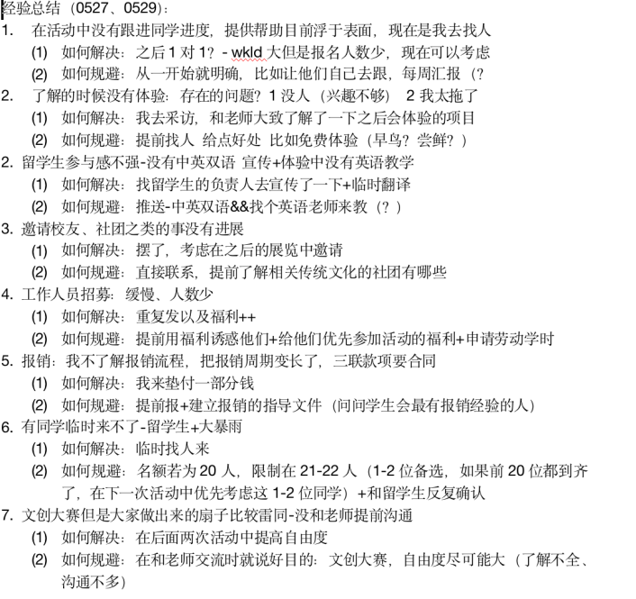

* 1. Improvement of publicity methods: online (unified style for the posts and subscriptions and joining in other social media)+offline
     1. Enhance offline promotion

Because of the pandemic, most of the activities turned online, and most of the publicity methods were through subscriptions. However, the subscription of student union, JIers, has limited publicity, and some students do not often read or check the subscription. Therefore, enhancing offline promotion, such as sending small stickers and creating small interactions, is beneficial for promoting activities to more people.

The offline promotion methods include:

1. Posting posters in Longbin Building and dormitories.

This has also been implemented in large-scale events previously, such as dances and Girls' Day.

1. Combining promotion with stalling.

For example, when setting up a stall in a small shop, promote new activities and encourage every student who comes to donate to participate. It can not only enhance inter departmental linkage, but also increase the visibility of the event and attract more audiences.

* 1. Unified style of subscription

The specific measures include a similar style of cover and title, the same color scheme for each semester, and a unified font. The Communication design can design a template and a cover every month. The workload is small but it can work efficiently. Of course, if there is a better idea in publicity (for example, the Ministry of Arts and Culture has higher requirements for the posts), you can make these posts your own. Another idea is to have a unified color scheme for the posts in one term. (e.g. The current idea is that the autumn semester is blue, the spring semester is green, and the summer semester is yellow.)

example:

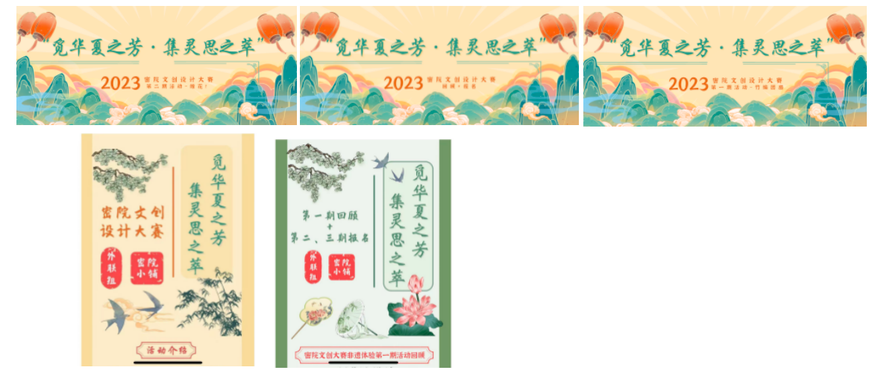

some advice for designing posts:

(you can see it in Chinese and in English in [Appendix.1.])

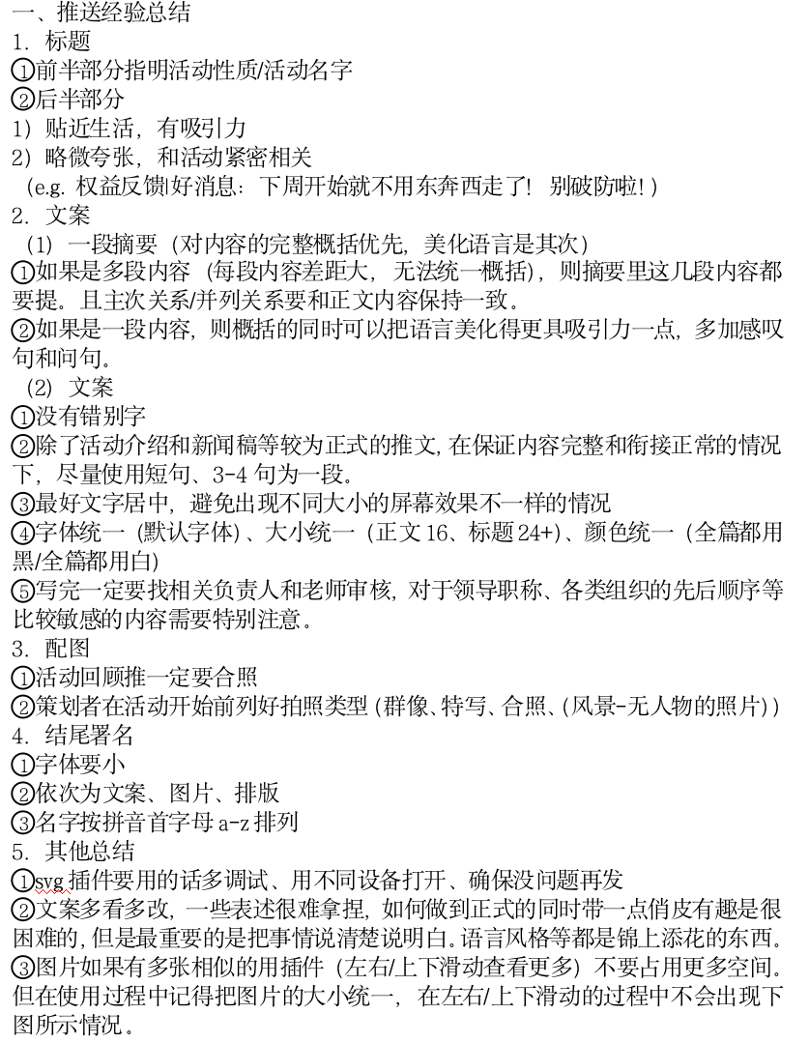

* 1. Restrictions of Members: concerning reducing the number of members, job rotation and their decisions of whether leave or stay after their freshman year

Reducing the number of people: control the number around 80

Member/Volunteer mobility: Provide department change channels at the end of each semester

Member/Volunteer retention: mid spring semester survey on volunteer retention intentions (leaving the following year/serving as an honorary department member/minister/chairman)

1. **Innovation**

Innovation is to enhance the experience of all the members in the Student Union. We should pay attention to students’ participation and experience during our work. The significance of a student union is to establish new activities or make changes to some content of the activities, integrating students' own ideas and characteristics. It is also a way for all students to get involved in student work to have a greater sense of belonging and experience.

The main implementation methods include:

1. For those projects with low participation:

First, improve them then if it doesn’t work, combine those with similar theme. If both improvement and combination don’t work, delete them.

1. During the interview, ask the ministerial team to propose new ideas(or the activities they want to hold but fail to hold, if so, state the reason of the failure) and integrate them into an idea list
2. Regularly collect new ideas
3. The organizing and planning team will coordinate and arrange multiple teams (such as teams responsible for post and on-site teams) to perform their respective duties. Each group leader is a student with experience in this field, and group members can be students with zero foundation but are interested in this field. The benefits of doing so are:
   * 1. Clear responsibilities;
     2. Volunteers break departmental boundaries and get to know more people in different activities;
     3. All student union volunteers who are interested in the activity have the opportunity to participate.
4. The direction of new ideas:
   1. Integrate with existing projects to enhance their attractiveness
   2. Open to freshmen to organize and plan (idea providers can assist in planning, but the main body of organizational planning is still freshmen volunteers [to better cultivate the ministerial/presidium])

This can solve a problem with the current "free working group": some students do not participate because they cannot think of new activities, resulting in low participation and ineffective performance.

1. **Students’ rights and interests**
   1. Inheritance**：**
      1. Combination of Long term activities and short term activities: long-term opening of equity platform+biannual dean meeting
      2. Diversified Rights Platform: SRC and Dean's Meeting
   2. Innovation:
      1. Set a theme for each quarter:

For example, technical issues (e.g. course selection website, computer software and hardware issues), optimization of living environment (e.g. about dormitories or classrooms), and issues related to course settings such as Turkey Day. Provide targeted feedback every quarter

* + 1. New position of internal communication department member: identifying problems and conducting research
       - 1. Benefit: Solve issues without proposals
         2. Requirement: Recruitment standards need to pay more attention to students' observation and research abilities

example:

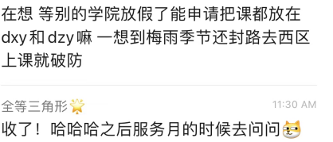

1. **Communication**
   1. Inheritance**：**
      1. Welcome international students to join various student organizations (especially student unions)
      2. Co-organizing activities with other colleges (Boys' Day, One Week CP)
   2. Innovation:
      1. Communication between colleges:

① Large scale events (Dianyuan, Antai)

② Long term communication: cultural exchange, experience sharing

* + 1. Invite clubs to introduce at the beginning of the semester
       - 1. Why are they willing to come?

Give them a stage to showcase/sponsor - combine the unique features of the secret courtyard with the opening ceremony of the cultural festival)

* + 1. Reasons for the current weak activities with clubs and other colleges:
       1. Our college has a well-established system, which is why it is relatively closed
       2. Three semester system, with a large gap in vacation time

1. **More thoughts**

* Functional hedging

(1) Integrated Media Center

① Coordinate publicity work

② Mainly responsible for press releases and providing images (students responsible for pushing in the media can also work in the Rong Media Center, but the Rong Media Center cannot steal people because the Rong Media Center has more resources and can find more non student union members)

(2) Youth League Committee and other subordinate organizations

Creating more cooperation and win-win situation

Collaborate,such as launching mechanical competition peripherals (Science and Technology Association×secret courtyard shops), such as AC

* About timeline
  1. Inheritance: Calendar+Mini Program
     + 1. Calendar
          1. Refine the duration of the activity (how many weeks, how many articles to push, when to post, and when to summarize experiences) and refine it to days at least one month before the activity starts (what to complete on the day of the month)
          2. Official account chronology - shared documents (so that no time hedging, and high update frequency can be guaranteed)

example:

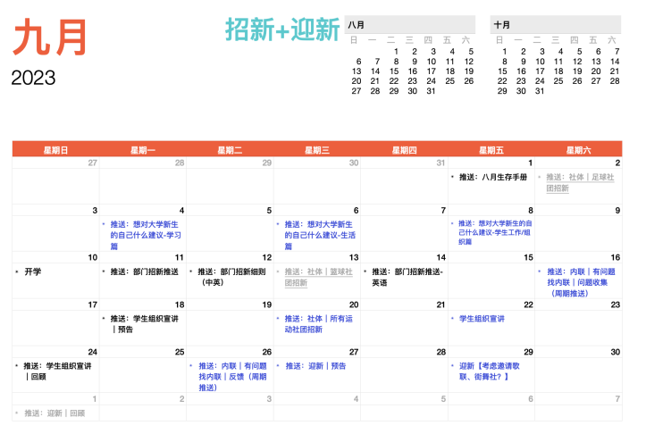

* + - 1. Mini program
         1. Promote offline and physical mini programs
         2. Enrich the content

Improvement: Add English version, Buddy related content, and cultural exchange related content for international students (purpose/positioning: to enable freshmen and students from other colleges to understand the Secret School and the Secret School Student Union)

* 1. Innovation:
     1. Internship Month (Strengthening Communication between Grades)
     2. Weekly report and monthly meeting (strengthen departmental communication)

[附录1]

[Appendix.1]

1. 推送经验总结
   1. 标题
      * 1. 前半部分指明活动性质/活动名字
        2. 后半部分
           1. 贴近生活，有吸引力
           2. 略微夸张，和活动紧密相关

（e.g. 权益反馈|好消息：下周开始就不用东奔西走了！别破防啦！）

* 1. 文案
     1. 一段摘要（对内容的完整概括优先，美化语言是其次）
        1. 如果是多段内容（每段内容差距大，无法统一概括），则摘要里这几段内容都要提。且主次关系/并列关系要和正文内容保持一致。
        2. 如果是一段内容，则概括的同时可以把语言美化得更具吸引力一点，多加感叹句和问句。
     2. 文案
        1. 没有错别字
        2. 除了活动介绍和新闻稿等较为正式的推文，在保证内容完整和衔接正常的情况下，尽量使用短句、3-4句为一段。
        3. 最好文字居中，避免出现不同大小的屏幕效果不一样的情况
        4. 字体统一（默认字体）、大小统一（正文16、标题24+）、颜色统一（全篇都用黑/全篇都用白）
        5. 写完一定要找相关负责人和老师审核，对于领导职称、各类组织的先后顺序等比较敏感的内容需要特别注意。
  2. 配图
     + 1. 活动回顾推一定要合照
       2. 策划者在活动开始前列好拍照类型（群像、特写、合照、（风景-无人物的照片））
  3. 结尾署名
     + 1. 字体要小
       2. 依次为文案、图片、排版
       3. 名字按拼音首字母a-z排列
  4. 其他总结
     + 1. svg插件要用的话多调试、用不同设备打开、确保没问题再发
       2. 文案多看多改，一些表述很难拿捏，如何做到正式的同时带一点俏皮有趣是很困难的，但是最重要的是把事情说清楚说明白。语言风格等都是锦上添花的东西。
       3. 图片如果有多张相似的用插件（左右/上下滑动查看更多）不要占用更多空间。但在使用过程中记得把图片的大小统一，在左右/上下滑动的过程中不会出现下图所示情况。

[附录2]

[Appendix.2]

1. 年历总述
   1. 9月招新
   2. 10月实习、筹备繁星周和午餐会
   3. 11月繁星周、午餐会、男生节、交大运动会
   4. 12月（寒假）小程序
   5. 3月舞会、女生节、春招、文化节开幕式
   6. 4月新生杯重启、一周cp
   7. 5月歌手大赛、文创大赛、体育赛事、小程序上新
   8. 6月服务月
   9. 7月学代会、部长团招新
   10. 8月军训、新老团队交接